Visual Capturing using OV7670 camera module:

Hardware Components:

* Arduino Uno
* OV7670 camera module
* Resistor 4.75K ohm
* Resistor 7K ohm
* Breadboard

Software Components:

* Arduino Ide
* JDK

Introduction:

The OV7670 image sensor is a small size, low voltage, single-chip VGA camera and CMOS image processor for all functions. It provides full-frame, sub-sampled or windowed 8-bit images in various formats, controlled through the Serial Camera Control Bus (SCCB) interface.

The camera module is powered from a single +3.3V power supply, and external clock source for camera module XCLK pin. The OV7670 camera module built-in onboard LDO regulator only requires single 3.3V power and can be used in Arduino STM32, Chipkit , FPGA and etc.

OV7670 Pin Diagram:

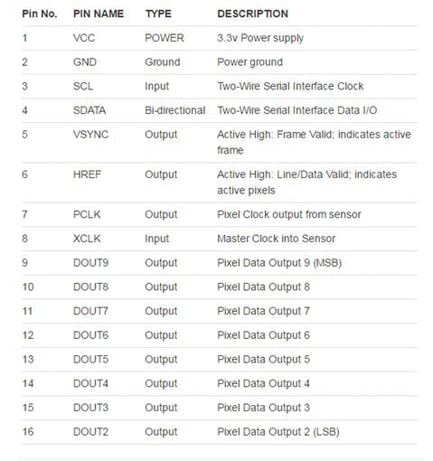

Module specification :

* Optical size 1/6 inch, Resolution 640×480 VGA
* Onboard regulator, only single 3.3V supply needed
* Mounted with high quality F1.8 / 6mm lens
* High sensitivity for low-light operation
* Automatic image control functions.
* ISP includes noise reduction and defect correction
* Supports LED and flash strobe mode ,Flicker (50/60 Hz) auto detection
* Saturation level (UV), Edge enhancement level auto adjust

Schematics:

**Schematics for the project**

